


Consulting report for

ABC Consulting Company
Consultant: Tran NGUYEN

Table of Contents
Executive Summary 2
Use Case Scenarios 3
Business Rules 3
Entity Relationship Diagram 4
Relational Data Schema 5
SQL Database 6
Forms 8
Instructions 12

Executive Summary
This report presents a comprehensive analysis of Best Mart’s sales performance and proposes a data management system designed to support strategic decision-making across departments. The primary goal is to enable the Sales and Marketing teams to quickly identify performance misalignments and take targeted actions to prevent quarterly losses. This is achieved through a diagnostic and descriptive dashboard that monitors Key Performance Indicators (KPIs), including Year-to-Date (YTD) sales, Average Daily Orders, and Daily Active Users. The system leverages a relational database to track active customers, providing critical insights into product quality and customer satisfaction — data that directly informs supply chain decisions.
Beyond sales and marketing, this report delivers significant value to the Supply team by enabling data-driven inventory optimization, regional demand forecasting, and supply allocation planning. By integrating sales performance with returned product data, the system identifies underperforming categories and regional discrepancies (e.g., Sylhet vs. Dhaka), allowing the Supply team to reallocate stock efficiently, adjust import volumes, and avoid overstocking or understocking. For example, insights into declining sales in specific product categories or regions can trigger timely adjustments in procurement and logistics, ensuring inventory aligns with actual demand.
The proposed solution includes a well-structured database, a user-friendly interface for data entry of returned products, and a real-time dashboard for cross-functional analysis. By combining sales, returns, and regional performance data, this system enables Best Mart to move from reactive problem-solving to proactive business optimization. This report details the use cases, business rules, data models, and implementation steps to ensure the system is scalable, accurate, and aligned with business objectives — ultimately supporting sales, marketing, and supply chain teams in achieving operational excellence and sustainable growth.

Use Case Scenarios
The following table outlines the use case scenarios that show how the system supports key business operations at Best Mart by enabling efficient tracking and analysis of sales performance and product planning. Key use cases include:
Department | Use case | Actors & Action | Goal
Sales and Marketing | Sales Performance Monitoring | The dashboard provides real-time KPIs such as YTD sales, average daily orders, and payment method trends to the Sales and Marketing team | This prompts a quick investigation of performance issues and helps Sales and Marketing team to take insightful actions
 | Trend and Regional Analysis | Market analyst can compare current performance with the same period last year (YoY) | This helps to analyze underperformance by region or product category to pinpoint root causes
The Supply Planning team | Resource and Inventory Optimization | The Supply Planning team uses the dashboard to evaluate the performance of different product categories. They identify that Medicine products are underperforming, while Beverages are exceeding targets. | Insights from return data and sales trends help guide inventory decisions, product strategy, and targeted interventions to improve overall business performance
 | Customer Return Processing | +) Customers submit return forms detailing the product, reason, and condition of the return.  +) Employees review each return, assess the item’s condition, and determine approval status (e.g., refund, exchange) | This information is used to improve quality control processes and renegotiate terms with suppliers. The employees’ review ensures accurate and consistent processing
Overall, the system enhances operational efficiency, supports data-driven decision-making, and helps prevent financial losses by enabling early detection and response to performance issues.

Business Rules
The system operates under a set of business rules designed to ensure data integrity, streamline return processing, support accurate analysis, and align with Best Mart’s operational and strategic objectives. These rules govern data processing, approval workflows, and reporting:
- Return Processing and Approval Workflow Rules:
- Each CustomerForm must have a corresponding EmployeeReview entry.
- The FormID in the EmployeeReview must match the FormID in the CustomerForm (referential integrity).
- The Returned_reason in the customer’s form must be updated before approval_status in the EmployeeReview set.
- The returned_method field must be selected from a predefined list
- The trans_id and product_id must exist
- Approval_time must be a valid date and cannot be in the future.
- KPI and Dashboard Reporting Rules
- Year-to-Date (YTD) Sales must be calculated based on completed orders only.
- Average Daily Orders is computed as total transactions in the period divided by the number of days.
- Daily Active Users is based on unique users who placed an order on a given day.
- Payment Method Distribution must exclude canceled or pending transactions.
- Top Product Categories are ranked by total sales revenue within a selected time frame.
- Trend and Analysis Rules
- Year-over-Year (YoY) comparisons are only valid when comparing the same calendar period (e.g., March 2023 vs. March 2024).
- Trend analysis is based on rolling 12-month and last 2 years data to account for seasonality.
- Data Security and Access Control Rules
- Customer info will be encrypted in cust_id
- Only authorized employees can access the EmployeeReview form.
- User roles determine access levels (e.g., customer support, sales manager, analyst).
- All data entries and modifications are logged for audit purposes.

Entity Relationship Diagram
The Entity Relationship Diagram (ERD) for the Best Mart system models the core data entities and their relationships to support customer returns and sales performance analysis. The main entities include:
- Customer: Stores customer information (e.g., CustomerID, Name, Contact), enabling personalized service and tracking of purchase behavior.
- Transaction: Records each sale (e.g., TransactionID, CustomerID, ProductID, Quantity, Amount, PaymentMethod, TransactionDate). This entity links customers to their purchases.
- Product: Stores product information (e.g., product ID, name, category, manufacturer country and suppliers’ information
- Store: Represents physical or online stores (e.g., StoreID, StoreName, Location), enabling regional performance analysis.
- Time: A time dimension table (e.g., Date, Day, Month, Year, Quarter) used to contextualize sales over time.
- Returned_form includes customer form & employee’s review: Captures customer return details (e.g., form ID, product ID, return reason, payment method) and records employee assessments of returns (e.g., return status, approval status, approval date).
Key Relationships:
- Customer → Transaction (one-to-many): One customer can make multiple transactions.
- Transaction → Product (many-to-one): Each transaction includes one or more products.
- Transaction → Store (many-to-one): Each transaction is linked to a specific store.
- Transaction → Time (many-to-one): Transactions are timestamped using the time dimension.
- CustomerForm → Transaction (one-to-one): Each return is tied to a specific transaction.

The ERD supports robust reporting, trend analysis, and decision-making by integrating customer behavior, product performance, store-level data, and temporal insights. This structure enables accurate tracking of sales, returns, and performance across regions and time periods.

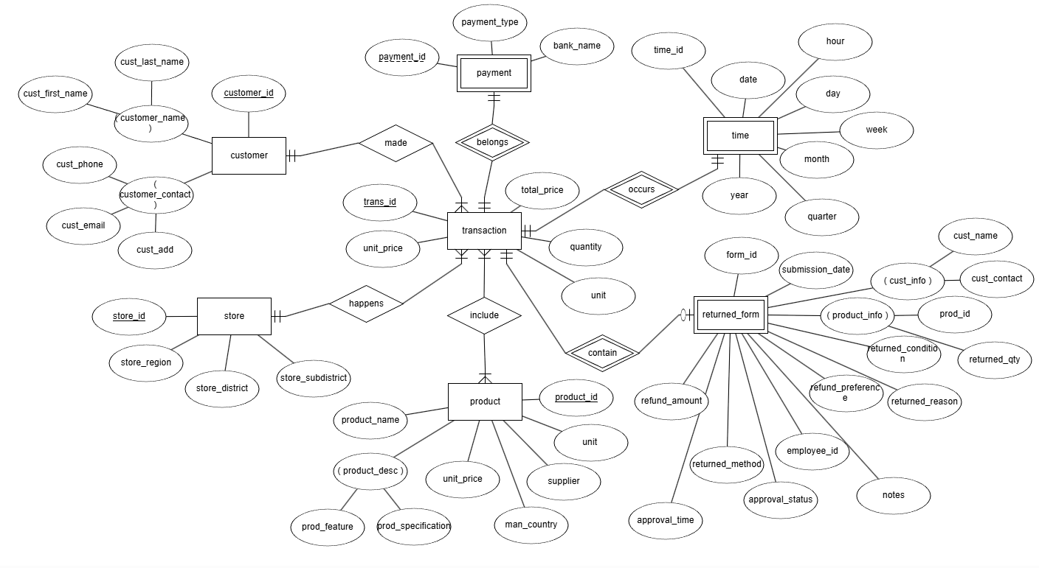

Relational Data Schema
The relational data schema for Best Mart is designed to support comprehensive sales, return, and performance analysis by organizing data into structured, normalized tables that maintain data integrity and enable efficient querying. The schema integrates key business entities: Customer, Transaction, Product, Store, Time, Returned Form into a cohesive database structure that supports both operational and analytical use cases.
The schema is built around a star schema model, where fact tables (e.g., Transaction) are linked to dimension tables (e.g., Customer, Product, Store, Time) to enable efficient querying and reporting. This design allows for flexible analysis across multiple dimensions such as time, location, product category, and customer behavior.

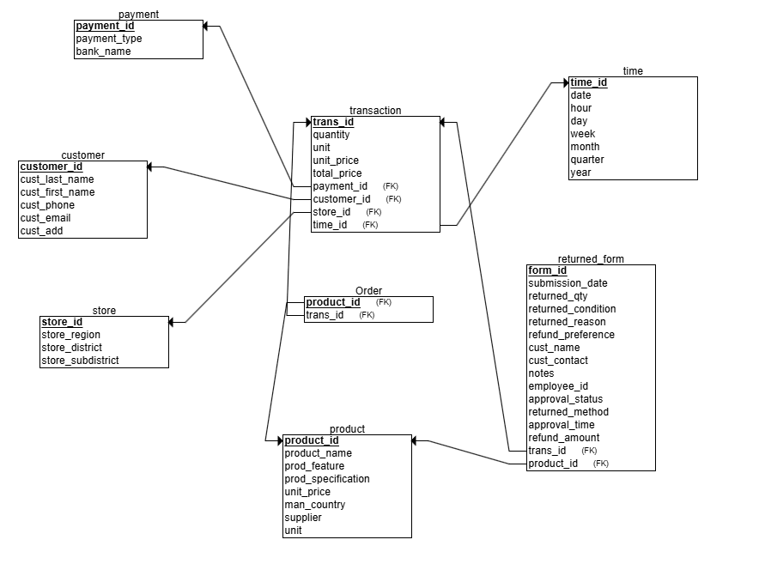

SQL Database
The Best Mart SQL database is designed to support business intelligence and performance analysis by integrating structured data from various operational sources. The core data entities: Customer, Transaction, Product, Store, and Time are initially populated by importing CSV files into the database. These files are loaded into their respective tables using SQL Server Management Studio.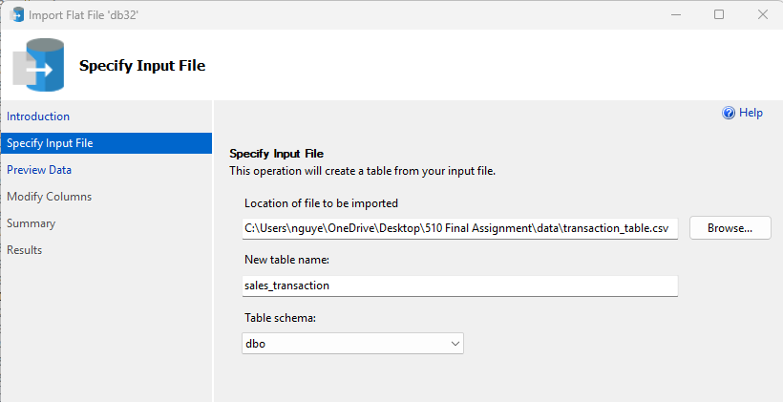
The returned_form is not imported from a CSV but is generated dynamically via SQL query as below. This is done by joining the Transaction and Product tables, identifying high-return products by using a record tracking of customer form and employees’ reviews stored in Excel Online. Then, those information will be synchronized by Power Automate to SQL database tables respectively.
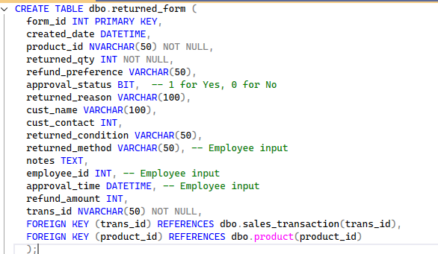

Forms
The returned form flows from Microsoft Forms → Excel Online → SQL Database, with Power Automate acting as the automation engine to sync data at every stage. This creates a seamless, automated return tracking system that supports both operational efficiency and strategic decision-making.
A customer submits a return for a damaged blender via Microsoft Forms at LINK: Returned Form – Fill out form.
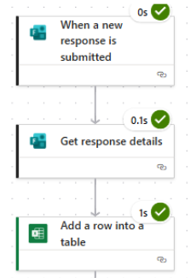
The form data appears in Excel Online at LINK: Best_Mart _ Returned_Form.xlsx
The employee reviews it and marks status. Power Automate detects the update and adds the record to the Returned_Form table in SQL. The dashboard now shows a spike in returns for "Coffee K-Cups" and triggers a review of supplier quality.

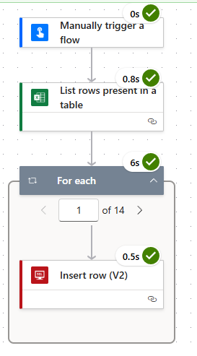

- Below is the customer’s returned form to submit:
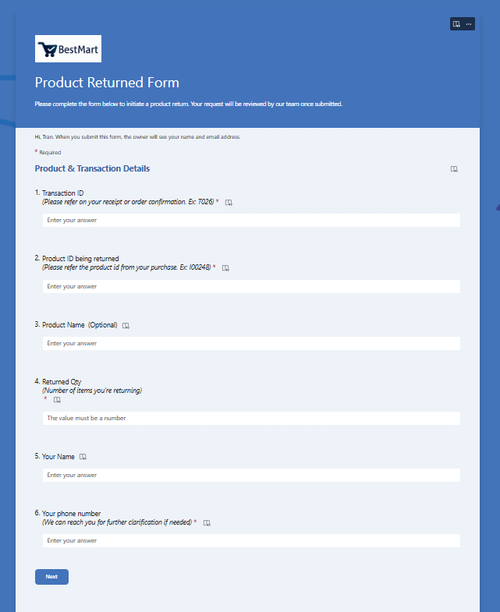
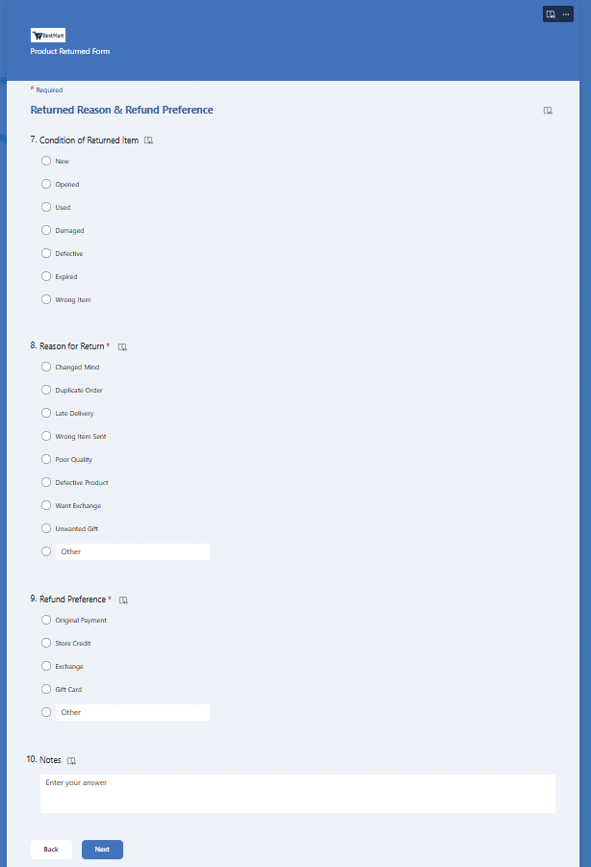
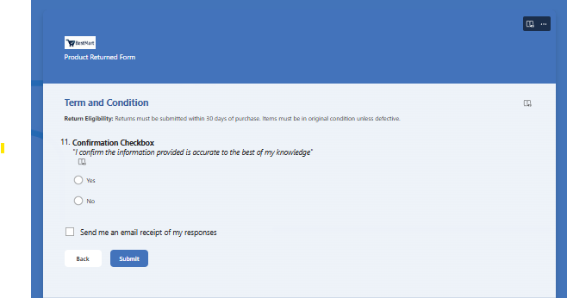

- Below is the employees returned form to review:
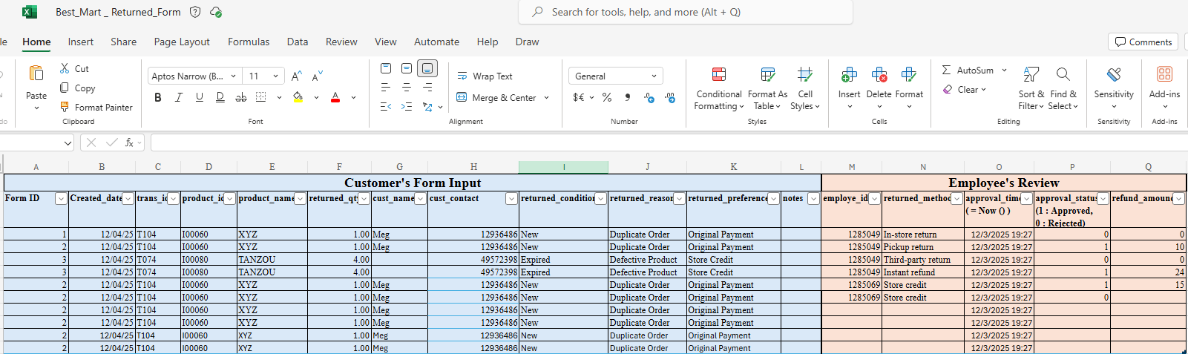

- Below is the summary of returned form in SQL Database:
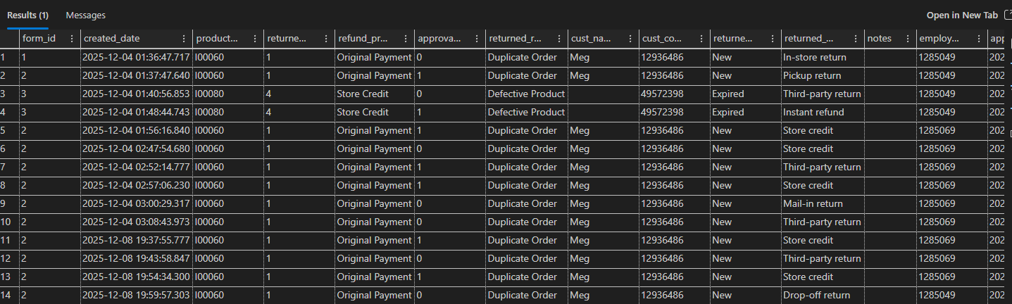

Instructions
This instruction explains how Best Mart staff can access, test, and evaluate the Azure SQL database system. It outlines the steps for using key features, verifying data accuracy, refreshing reports, and submitting feedback during the POC stage

- Login information for SQL database:
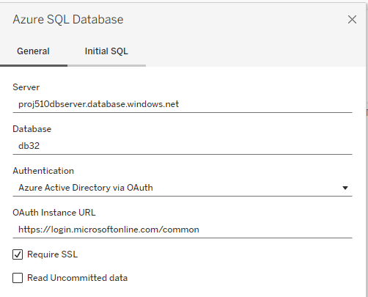
Server: proj510dbserver.database.windows.net
Authentication type: Microsoft Entra ID
Account: UW email address
Database: db32

- Login information for Form
Using your email …..@uw.edu to access the customers returned form: Returned Form – Collaboration
Using your email ….@uw.edu to access the employees review: Best_Mart _ Returned_Form.xlsx

- Login information for Tableau project 